Chess Game Semester Project

Muhammad Taha | 25F-0755
Hiba Eman | 25F-0596
Section | BCS-2B
Submitted to | Mam Amna Waheed

- We made chess game using Object Oriented Programming Concepts in CPP.
- We did class hierarchy, implemented valid moves, input validation, internal console based GUI and external GUI using SFML.
- Class Heirarchy i.e. there is one parent abstract class Piece. Other actual pieces like King, etc inherit from piece.
- We kept main function clean.
- We did all our work using Three File Structure.
- We implemented the logic of SAVE and LOAD GAME at run time by doing file handling.

Screenshots
GUI Game:
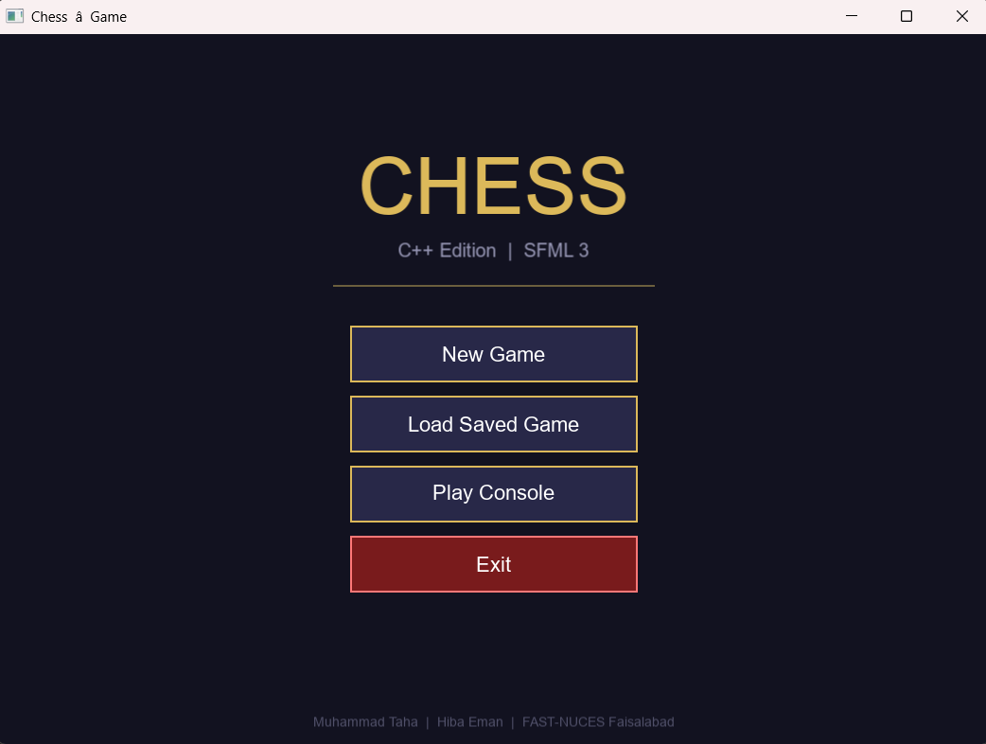
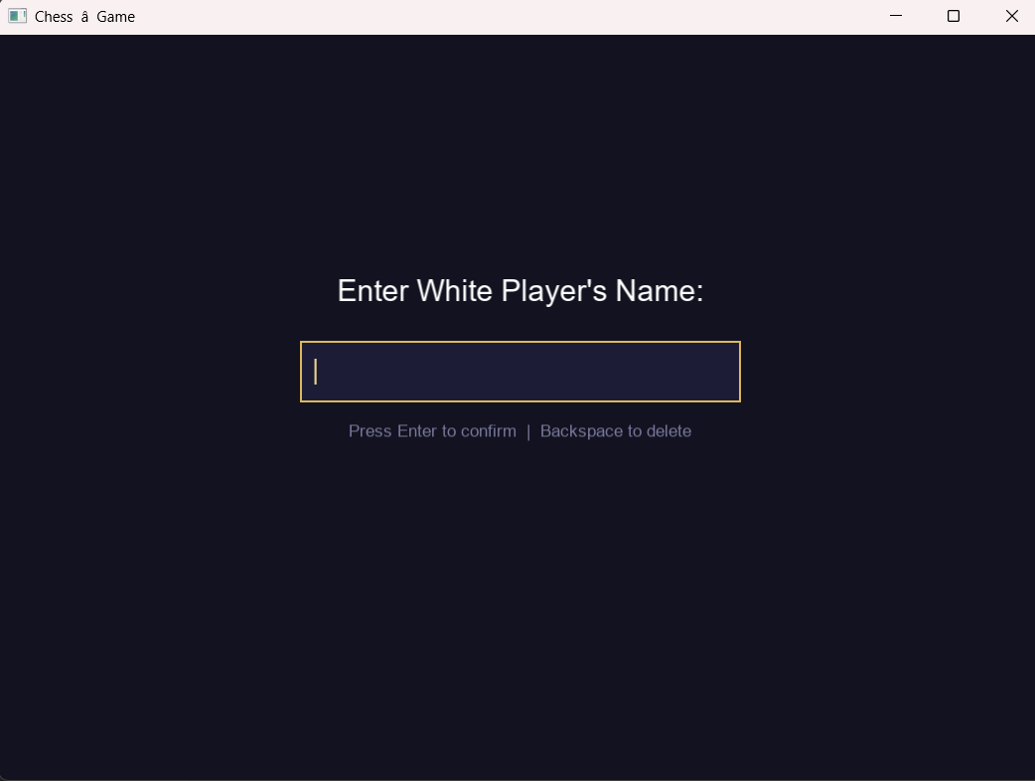
Similary Black Enter’s the name.

Game Interface:
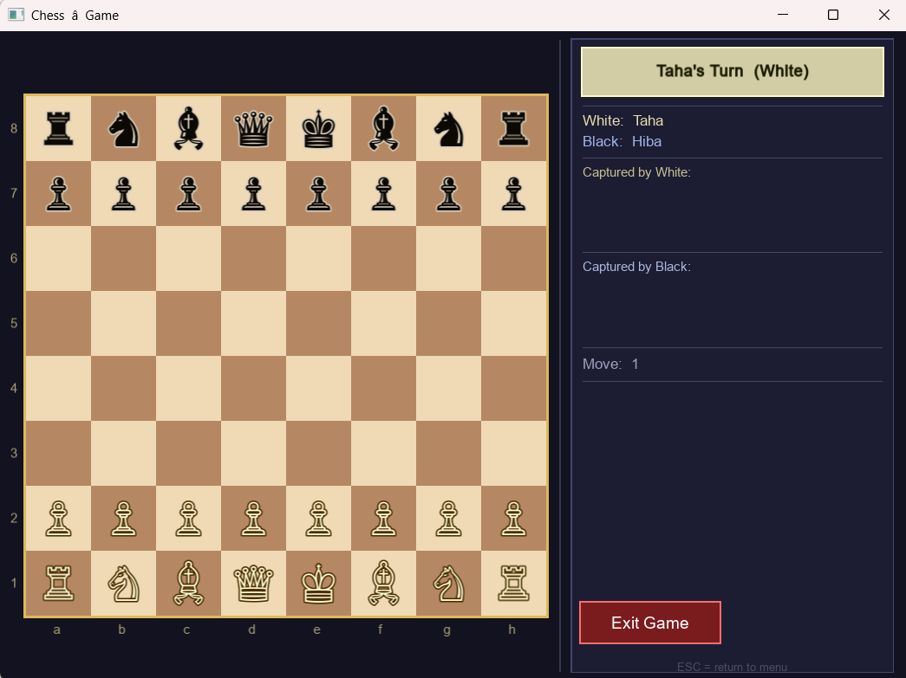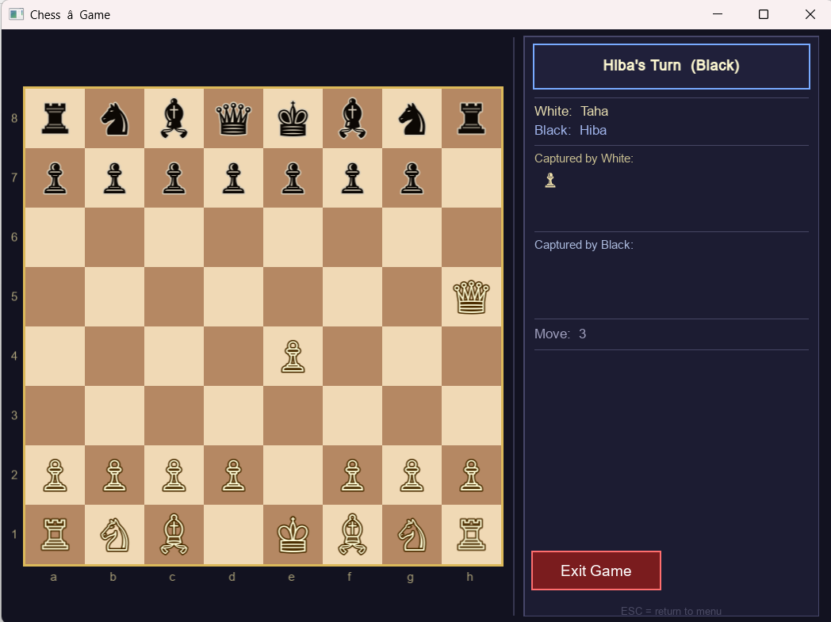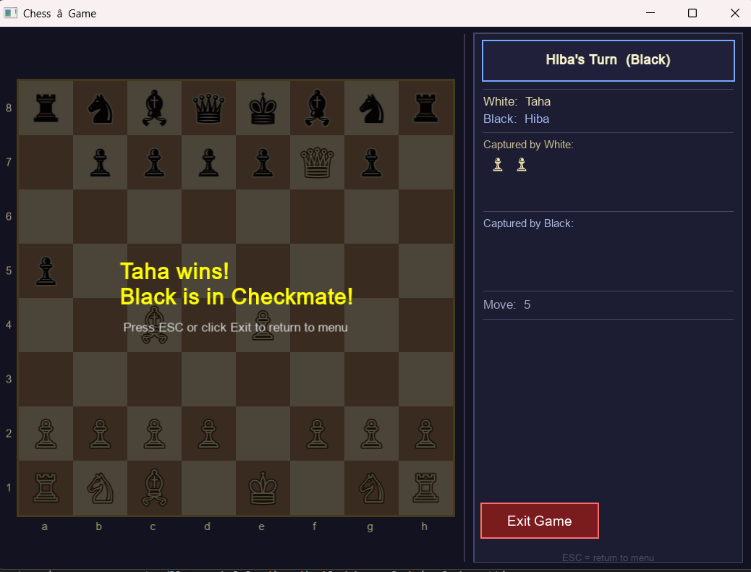

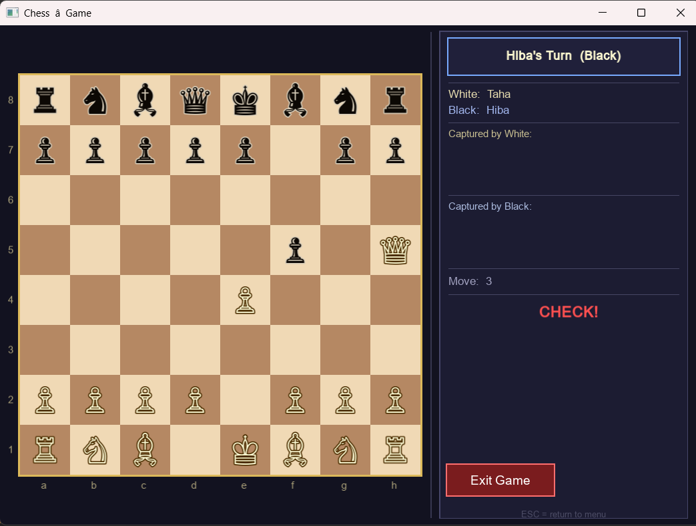

CONSOLE BASED CHESS GAME SCREENSHOTS
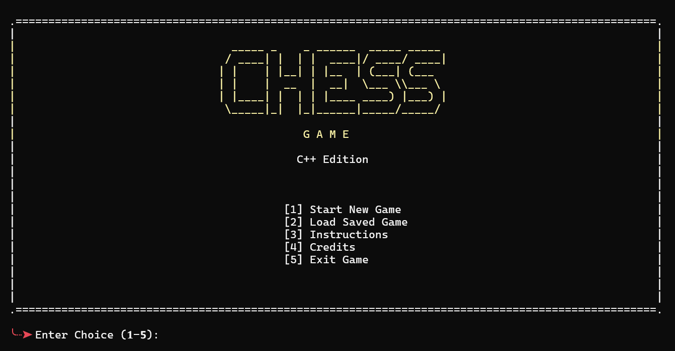

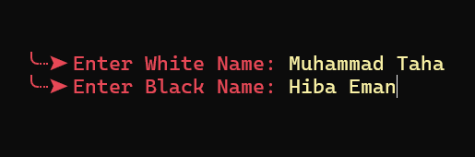

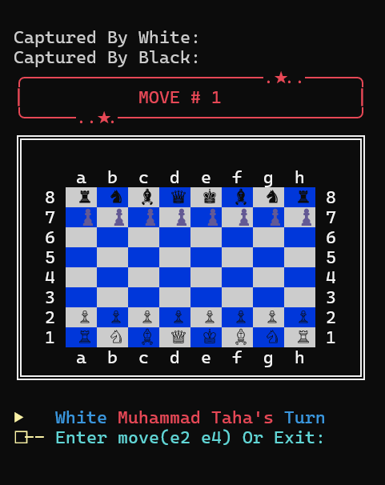

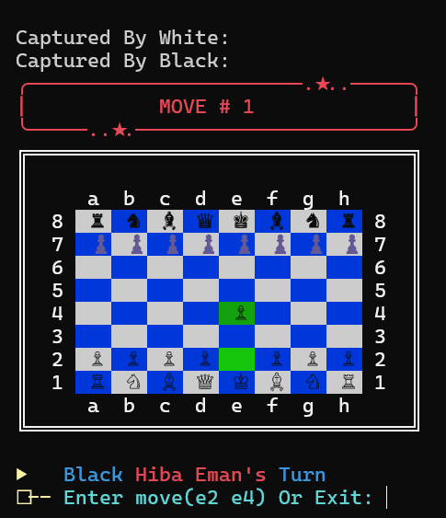
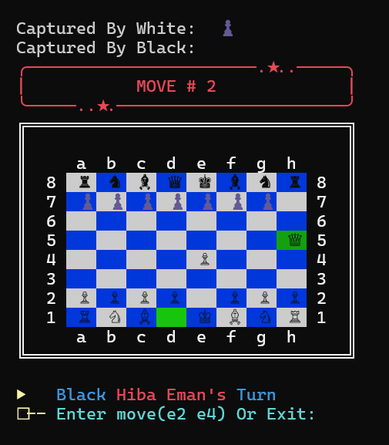

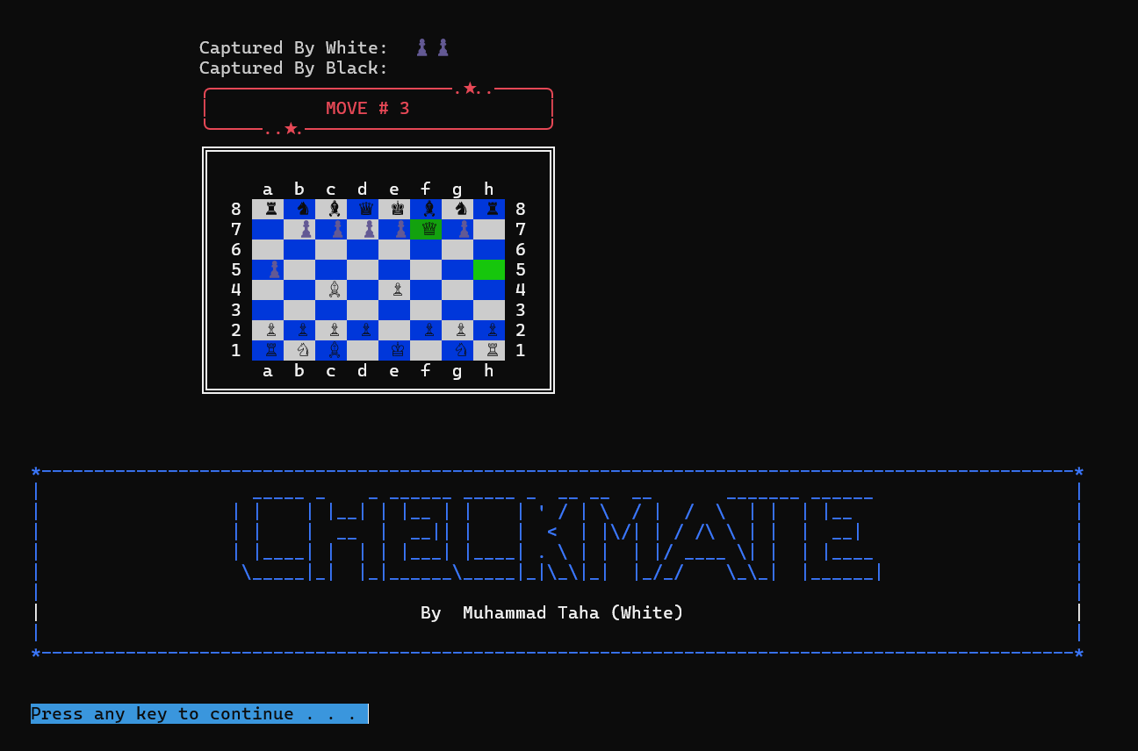
Each move gets saved and we can also play previously saved game whenever we want.
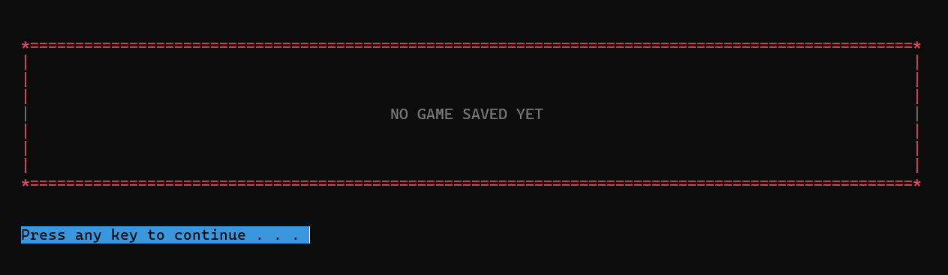
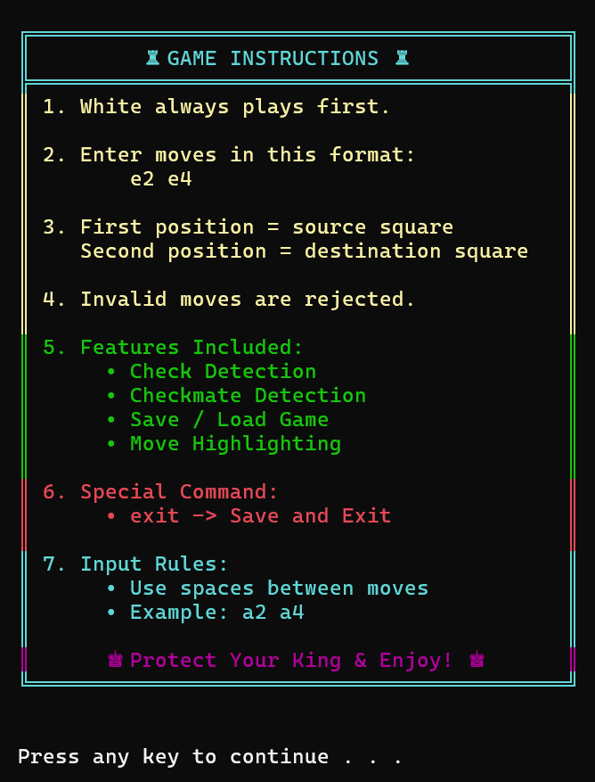

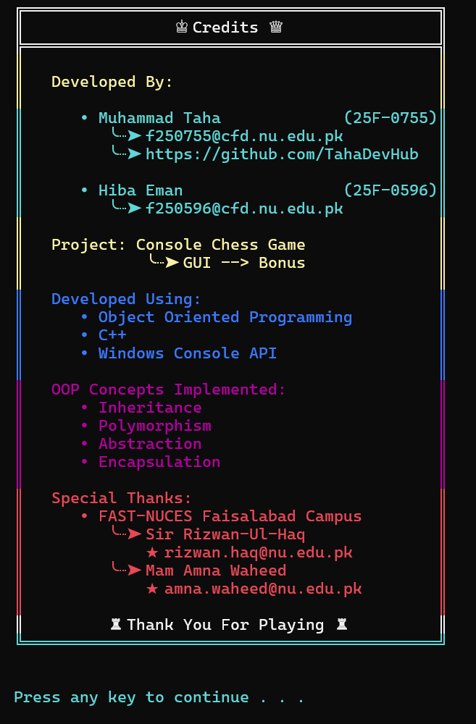

On entering 5
